**Job Portal Website**

**Project Report**

Major Project (IMW651)

Degree

**BACHELOR OF COMPUTER APPLICATION**

**(Mobile Application and Web Technology)**

|  |  |
| --- | --- |
| PROJECT GUIDE:  **Mr. Sanjeev Soni**  **(Senior IT Faculty, CCSIT, iNurture)** | SUBMITTED BY:  **Enrollment No: TCA2055005**  **Name: Purushartha Singh Thakur** |

May, 2022



**FACULTY OF ENGINEERING & COMPUTING SCIENCES**

**TEERTHANKER MAHAVEER UNIVERSITY, MORADABAD**

**Acknowledgement**

We would like to express our special thanks to our guide, Mr. Sanjeev Soni, who provided us the golden opportunity to work on the project “Job Portal Website” created using the MERN stack. While working on this project, we have gained a lot of valuable knowledge and experienced working on the project as a team. We express our wholehearted thanks to our mentor/guide.

Place: Teerthanker Mahaveer University (Moradabad)

Date: 01/03/20

**DECLARATION**

I hereby declare that this Project Report titled **Job Portal Website** submitted by us and approved by our project guide, Mr. Sanjeev Soni, is a bonafide work undertaken by us and it is not submitted to any other University or Institution for the award of any degree diploma / certificate or published any time before.

|  |  |  |
| --- | --- | --- |
| **Project Name :** | Job Portal Website | |
| **Student Name:** | Purushartha Singh Thakur | Signature |

Table of Contents

1 Project Title 5

2 Domain 5

3 Problem Statement 5

4 Project Description 6

4.1 Scope of the Work 7

4.2 Project Modules 7

5 Implementation Methodology 7

6 Technologies to be used 9

6.1 Software Platform 10

6.2 Hardware Platform 10

6.3 Tools 10

7 Advantages of this Project 10

8 Future Scope and further enhancement of the Project 11

9 Team Details 12

10 Conclusion 12

11 References 13

12 Project Outcome 14

# Project Title

The project title is ‘**Job Portal Website’**. It will serve as a platform for job seekers and employers to connect. It will allow job seekers to create profiles, search for and apply to job listings, while employers can post job openings, browse resumes and contact candidates.

# Domain

**Web Development (Job Portal).** In the present scenario, everything in the world has been digitalized and is available at the click of a button in a matter of few seconds, this is possible with the advancement in the field of web. It provides a means of creating innovative and engaging websites/applications for the users. These websites can be accessed from anywhere and at any time with an internet connection making it one of the most popular choices for the general public to easily gain information, entertainment and many other needs.

# Problem Statement

The aim of the project is to build a website to connect job seekers with potential employers with tools to create profiles, search for and apply to job listings, and receive job alerts. Employers can use the platform to post job openings, browse resumes, and contact candidates.

In job portals, there is no foolproof way to filter all fake job notices, as scammers are constantly finding new ways to bypass the current filtering system and post fake notices. In order to handle such problems, this job portal will verify the authenticity of job notices.

# Project Description

As mentioned earlier, for the beta version this project will be able to support a small number of users utilizing all the available resources to the utmost.

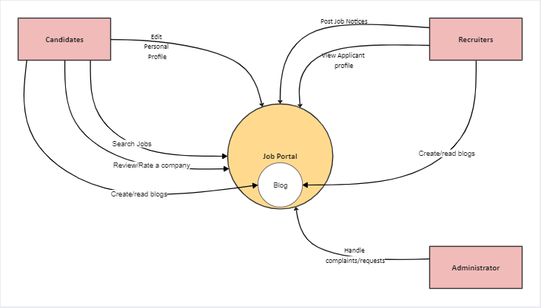

**Context Diagram**

As shown in the above diagram, the website can be accessed by multiple users who can login/signup on the website and can browse and apply for the jobs as a job seeker or post a job as a recruiter.

They can also read and write blogs in the blogs section. For job seeker’s, they will also be able to provide their ratings and reviews regarding the company and their work environment or about their experience in the interview process.

## Scope of the Work

The project will allow users to Login/Signup onto the Platform. The Signup process will include the authentication/authorization by the server. In case of a recruiter signup, they will be asked for their company information. On Successful Login the user will be redirected to home page of the platform and from there the control is in the hands of the user. The options are browsing the job listing, editing their profiles, reading/writing blogs, posting job notices, applying for jobs, searching jobs, tracking application.

## Project Modules

The project backend will contain the following modules:

1. Database- It contain the database schema file and the models for each document in the MongoDB cluster.
2. Entities- It contain the routes for the project as well as the Controllers and services.
3. Node Modules-contains node modules installed during node setup.
4. Static- It will contain the static files used in the projects like scripts, CSS files, images, etc.
5. Middleware-This directory contains the middlewares that will be used in the server for proper navigation and for implementing certain functionalities.
6. Uploads- It contains the files that will be uploaded by the users.
7. Views- It will contain the views of the website.
8. Index.js- It is the main setup file for the server.
9. Package.json- these files contain information regarding the project like author name, dependencies, text scripts, etc.

The project frontend will contain the following modules:

1. Public-contains static files such as index. html, java script library files, images, and other assets, etc. which you don't want to be processed by web pack.
2. Src-contains working files that will be used later to create the build.

# Implementation Methodology

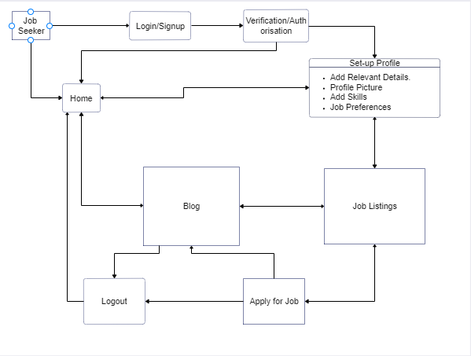

**Data Flow Diagram (Job Seeker)**

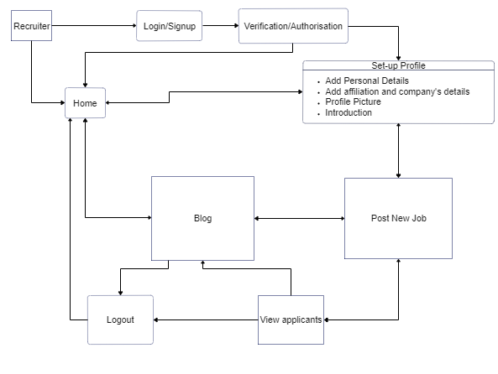

**Data Flow Diagram (Recruiter)**

The above diagrams show the **data flow** from the moment user logs in to the website till they logout.

The user will land on the home page from where user can navigate the website and explore the job listings and search for jobs as needed. On successful login, they will be routed to home page else they will be redirected back to the login page for signup or in case of invalid credentials. From the home page user can then proceed to create their profile or navigate through the site to the blogs section where they can read/write blogs. They can apply for jobs or post a job notice (for recruiters). The recruiters will be able to view the list of applicants for their notice.

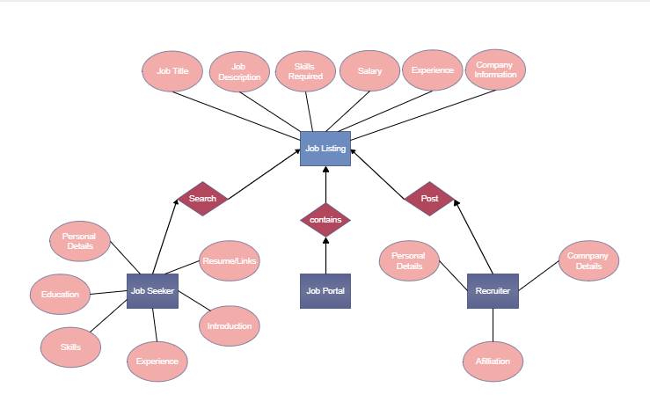

**ER Diagram**

The image contains the rough **ER diagram** for the MongoDB documents:

There are 3 strong entities, i.e., job portal, recruiter, job seeker. All of these have some relationship with the weak entity Job Listing. Each of these entities have their own attributes that will completely describe their behavior and use.

# Technologies to be used

The following technologies are utilized for this project. This list may change as need for more features/improvements arises in the future.

## Software Platform

1. **Front-end**

* HTML5- HTML5 is the latest and most enhanced version of HTML.  HTML is the standard markup language for documents designed to be displayed in a web browser.
* CSS3- Cascading Style Sheets is a style sheet language used for describing the presentation of a document written in a markup language such as HTML.
* ReactJS- free and open-source front-end JavaScript library for building user interfaces based on UI components.
* Material UI/Tailwind CSS.

1. **Back-end**

* NodeJS- open-source, cross-platform, back-end JavaScript runtime environment that runs on a JavaScript Engine and executes JavaScript code outside a web browser, which was designed to build scalable network applications.
* ExpressJS- back-end web application framework for building RESTful APIs with Node.js.

1. **Database**

* MongoDB- cross-platform document-oriented database program.

## Hardware Platform

* 4 GB RAM
* 500gb Hard Disk,
* Windows 10

## Tools

During the planned development phase, the main tool is **VS Code v1.71** by Microsoft used as an editor for quick and precise development of the project, **Google Chrome v105.0.5195** by GOOGLE used as a tool for testing, debugging and front-end development.

# Advantages of this Project

The main advantages of this project are:

* Candidates can view their past applications
* Users can read and write blogs.
* Through the Profile section, candidates can gain insight on where to improve in order to increase their chances for employment.
* Users can preview their profile preview.
* Recruiters can view the profiles of candidates.

# Future Scope and further enhancement of the Project

In the future according to the need/demands of the users, new features such as built-in ATS (Application Tracking System).

For the design improvements CSS extension language such as SCSS will be used to provide further compatibility with other browsers such as Opera, IE, MS Edge, Safari, etc.

# Team Details

| **Project Name & ID** | **Course Name** | **Student ID** | **Student Name** | **Role** | **Signature** |
| --- | --- | --- | --- | --- | --- |
| Job Portal Website | Major Project | TCA2055005 | Purushartha Singh Thakur | Designer, Developer |  |
| TCA2055008 | Tushar Kumar | Tester |  |

# Conclusion

Through this Job Portal Website, I will tackle the problem of fake job notices to relieve potential job seekers of any worries and provide them with a trustworthy platform to pursue their careers. The recruiters can also easily interact with the candidates from within the portal saving them any hassle of going through other means of communication.

For future improvements, search will be optimized to make the results better suit the skills of the seeker and providing the recruiters with the best possible candidate to match their requirements.

# References

1. <https://www.npmjs.com/-> The official Node Package Manager Website that will be used for downloading and utilizing the various dependencies.
2. <https://stackoverflow.com/-> The technical forum for any queries that arise during the development phase of the project.
3. <https://github.com/> - Service which has detailed wikis regarding similar projects.
4. <https://developer.mozilla.org/en-US/docs/Web/JavaScript-> A documentation repository to gain further knowledge on usage and implementation of various modules/functionalities in JavaScript, HTML5 and CSS3.
5. <https://css-tricks.com/-> Articles on efficient and improved usage of CSS properties to achieve the desired interface.
6. <https://www.mongodb.com/docs/-> Documentation for the MongoDB database and the details of the features , how to implement them.
7. <https://mongoosejs.com/docs/-> Documentation for the Mongoose module of NodeJS, used to define the schema of a NoSQL database, models and other such details.
8. <https://expressjs.com/-> Documentation for the Express module of NodeJS, provides detailed tutorial and best practices for the development of a project.

# Project Outcome

Home

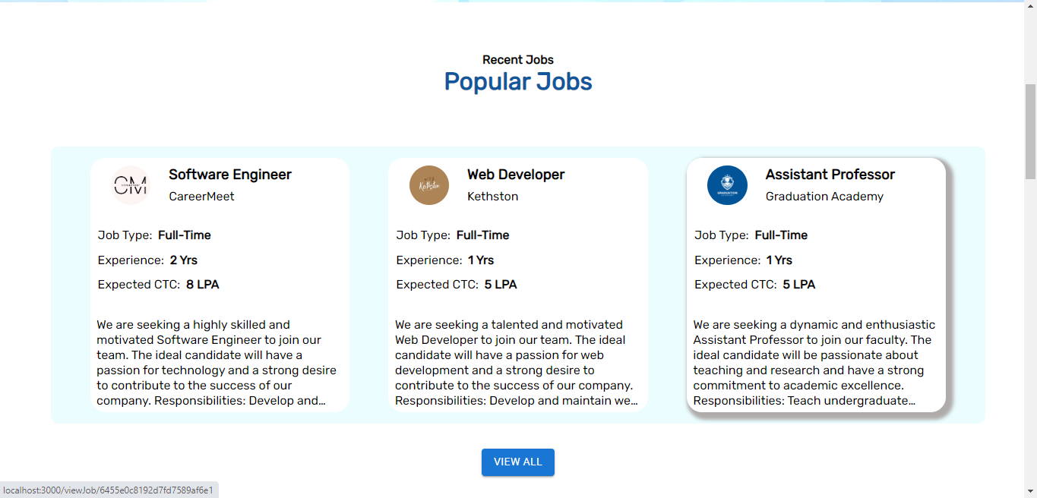

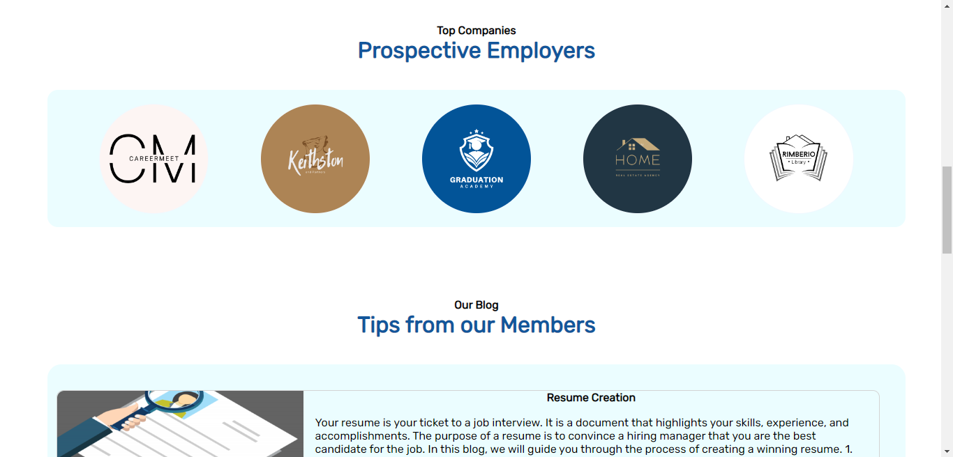

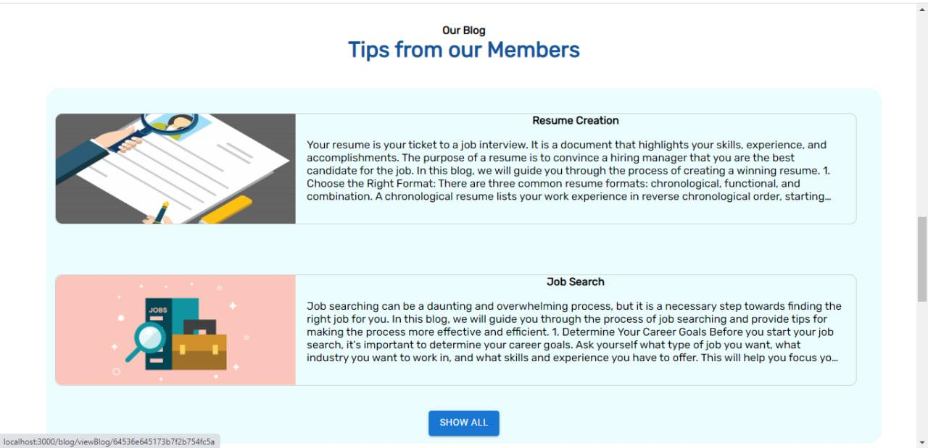

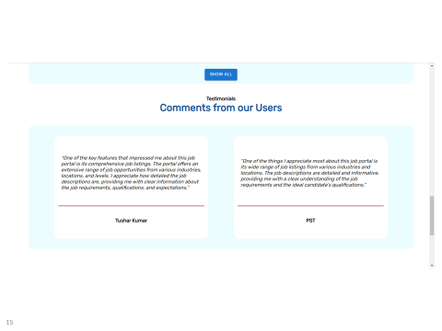

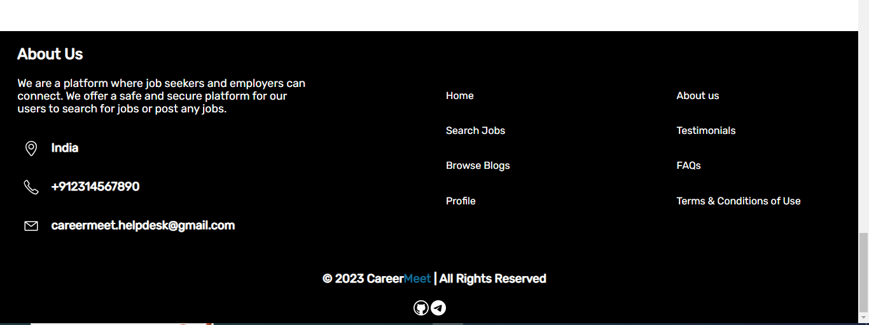

Search

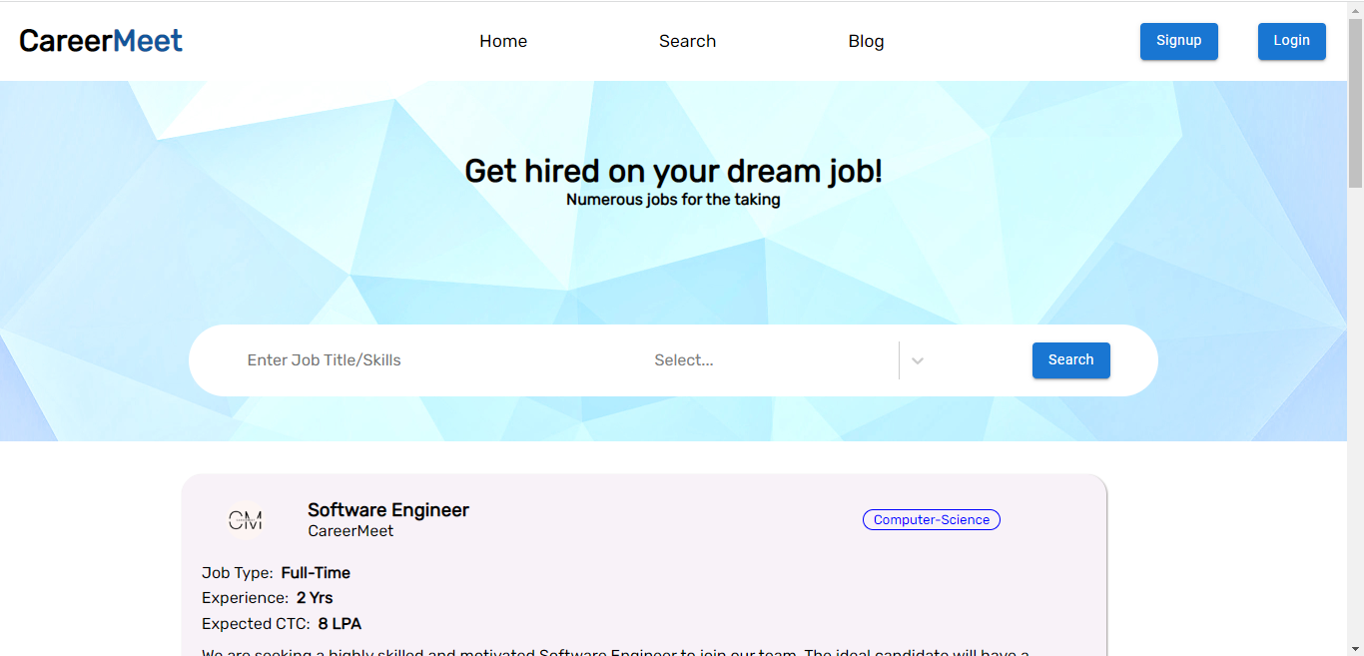

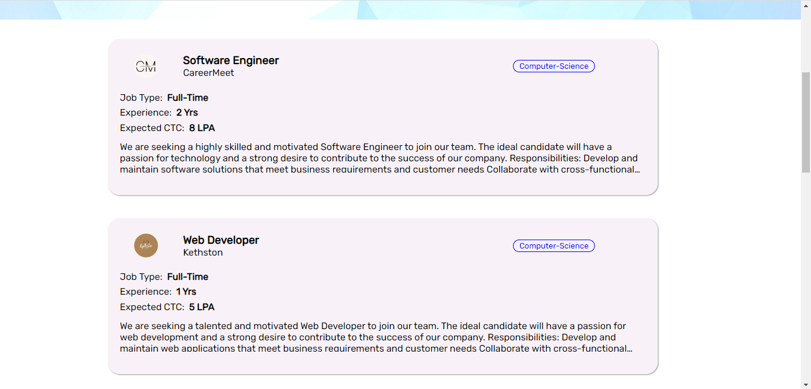

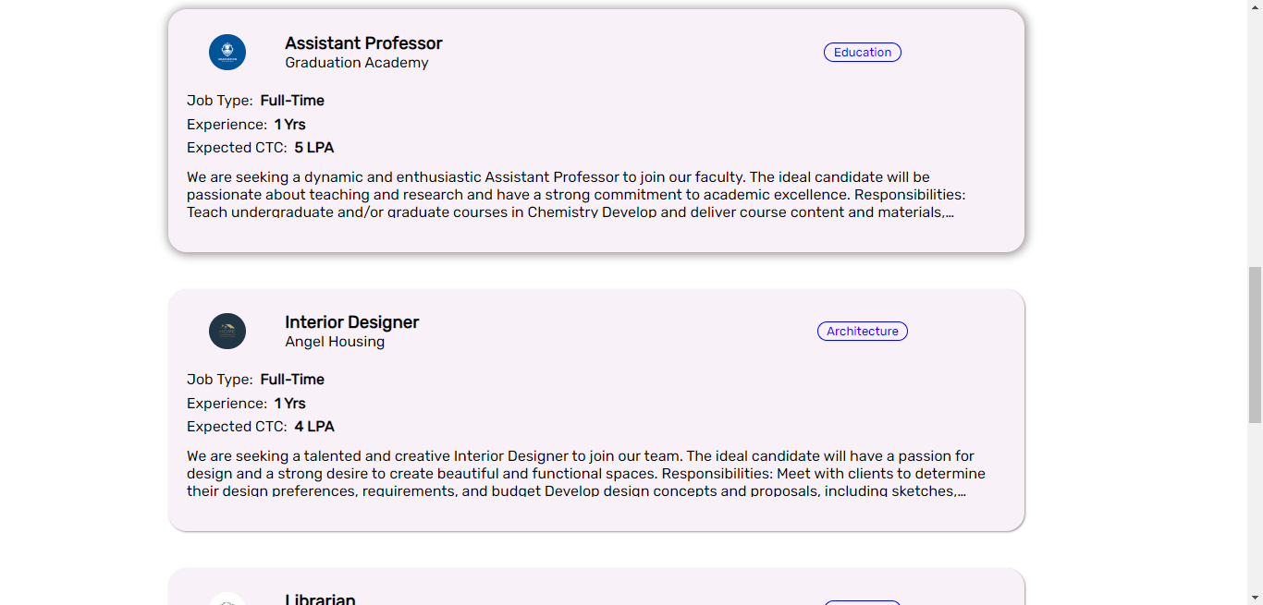

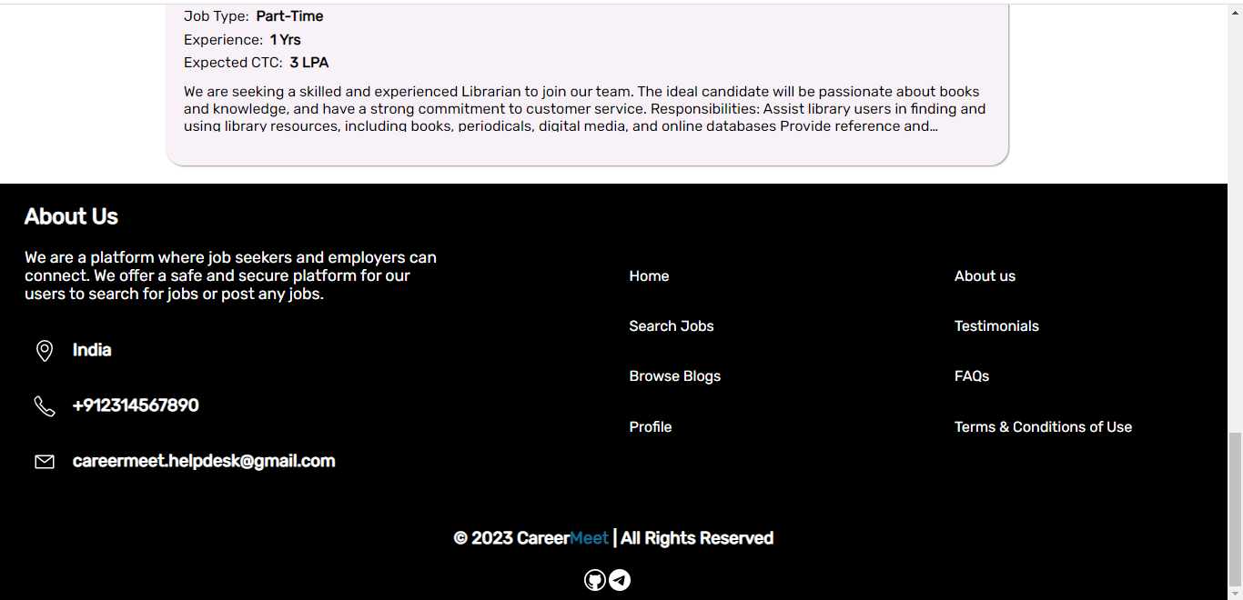

Blog

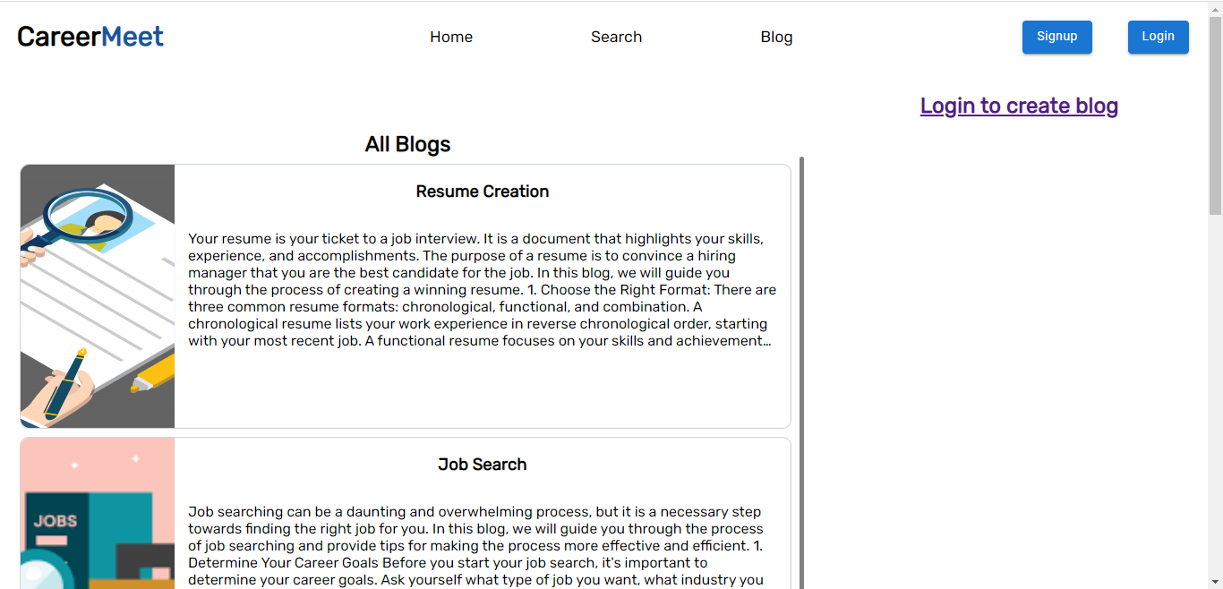

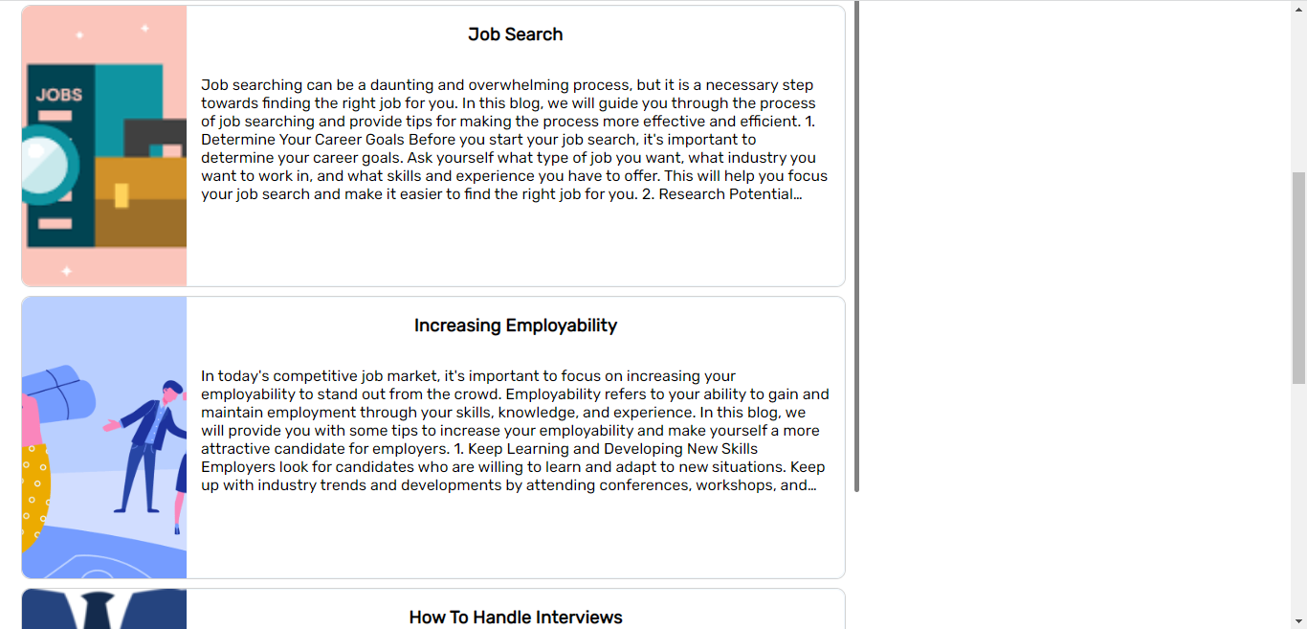

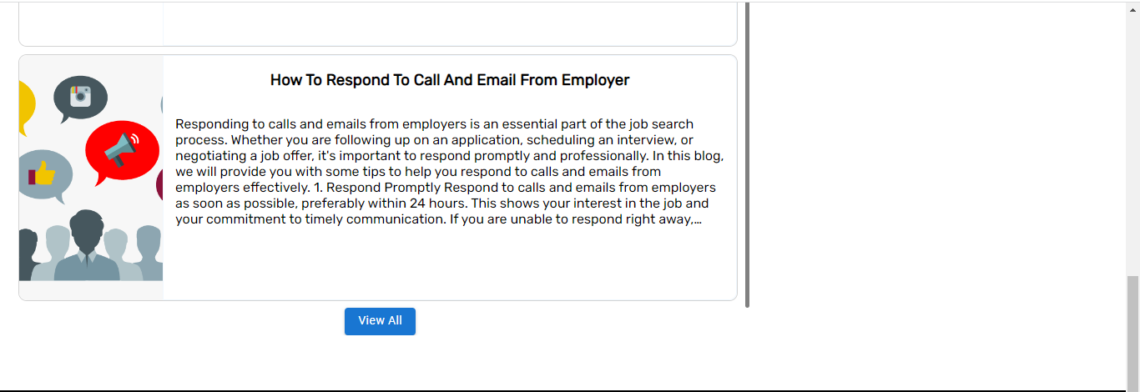

Signup (Candidate)

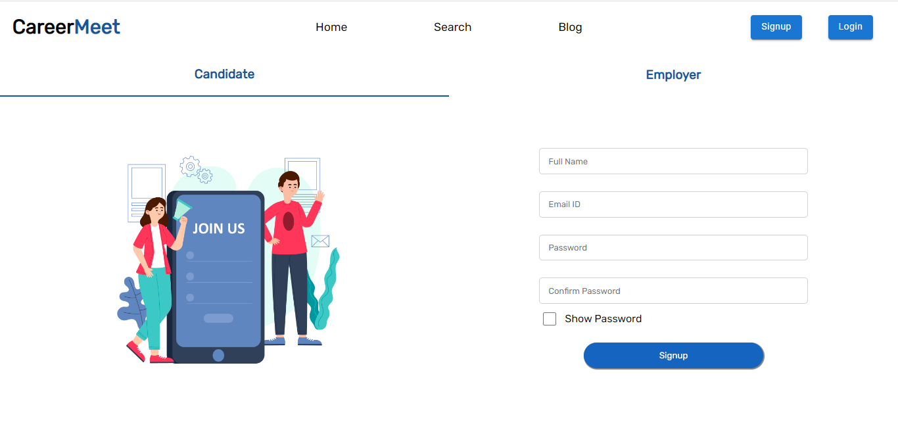

Signup (Employer)

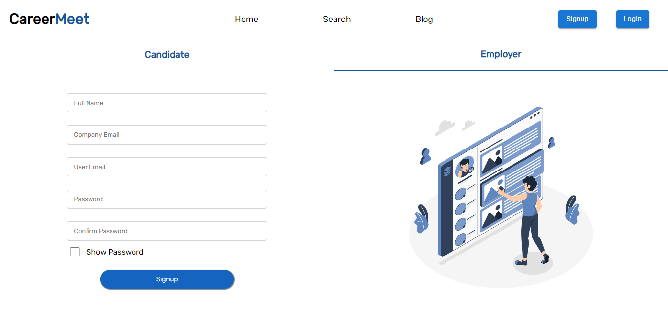

Login

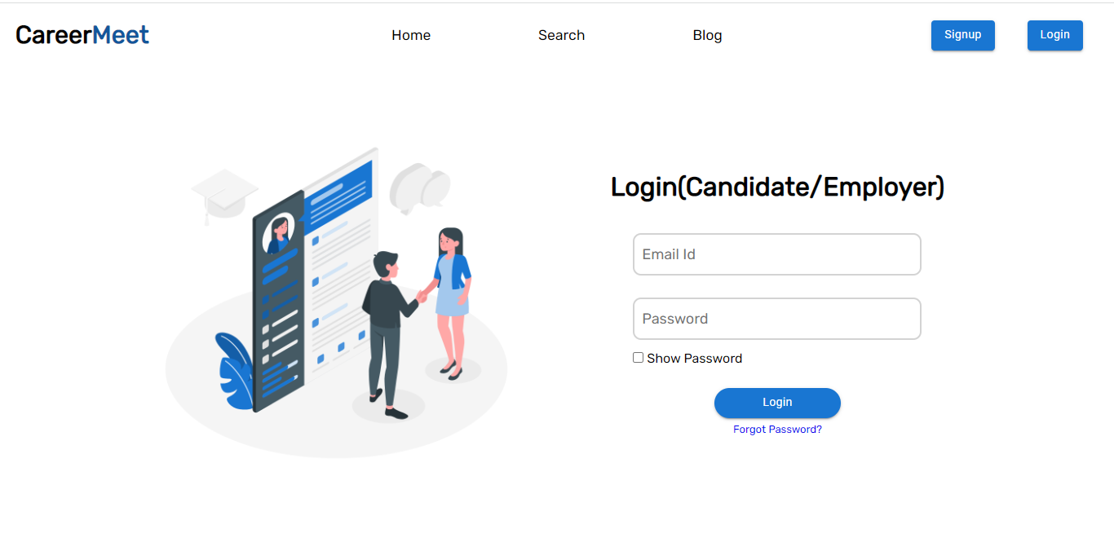

Authenticated Home (After user login)

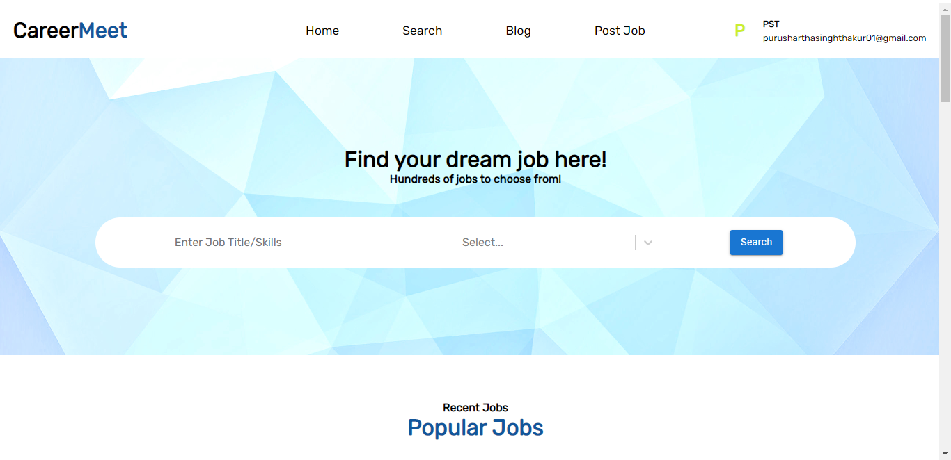

Blog (After user Login)

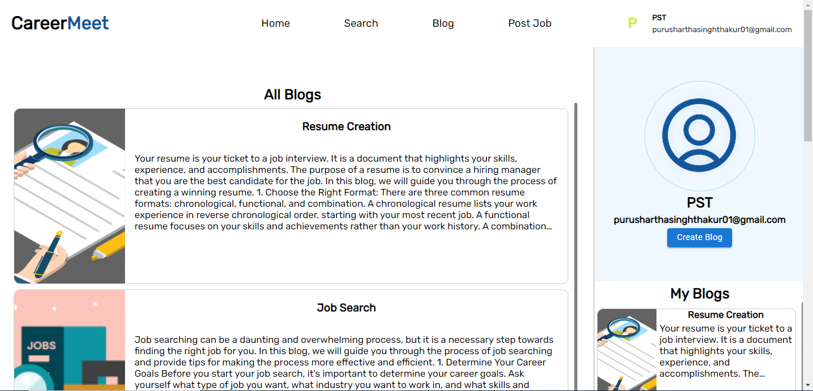

Create Blog

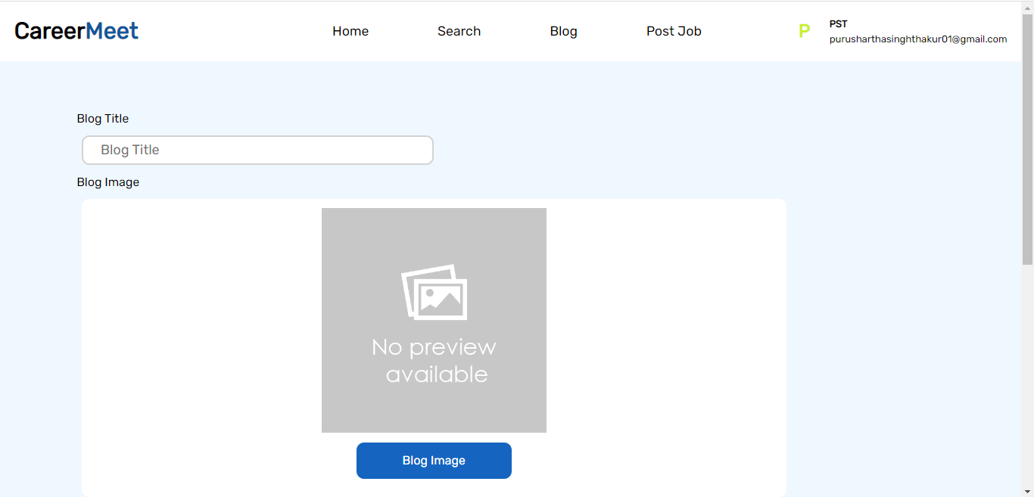

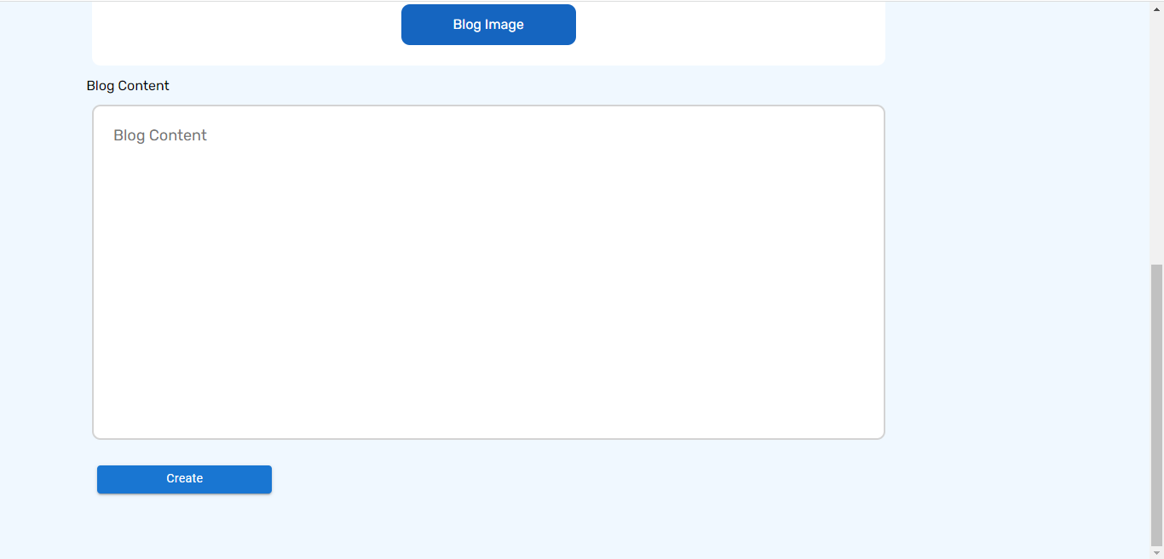

Profile

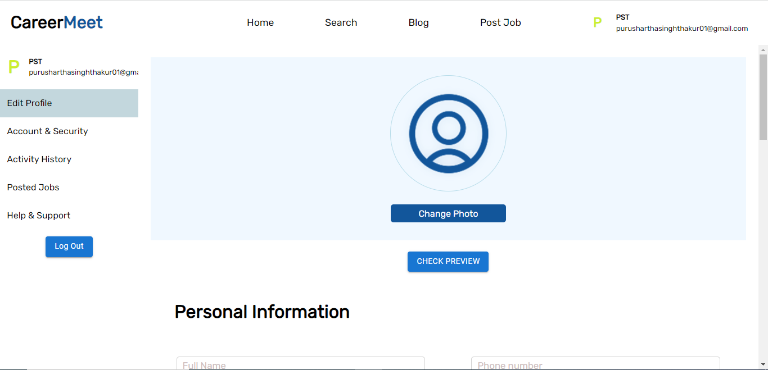

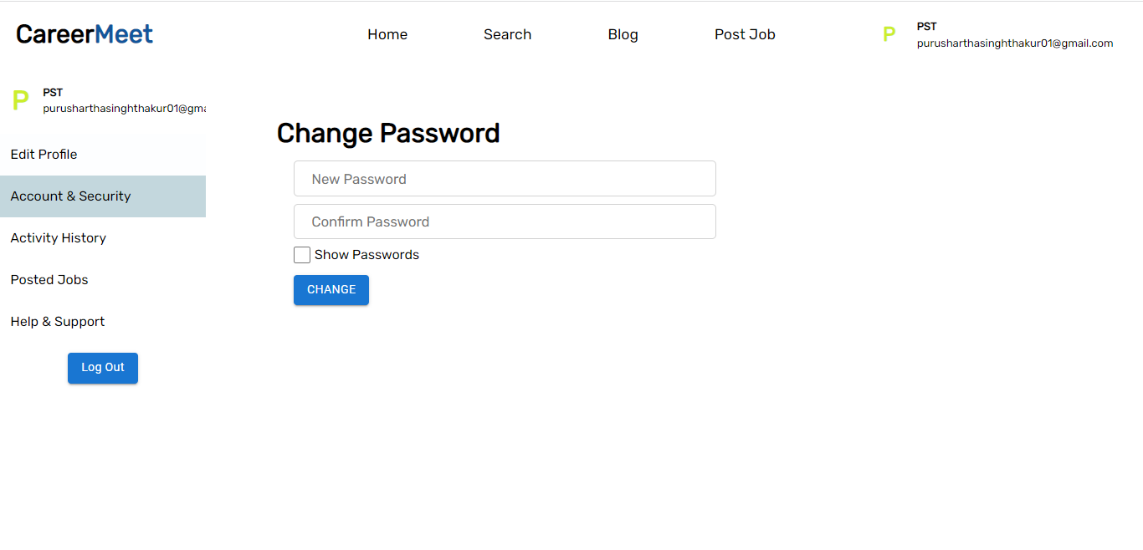

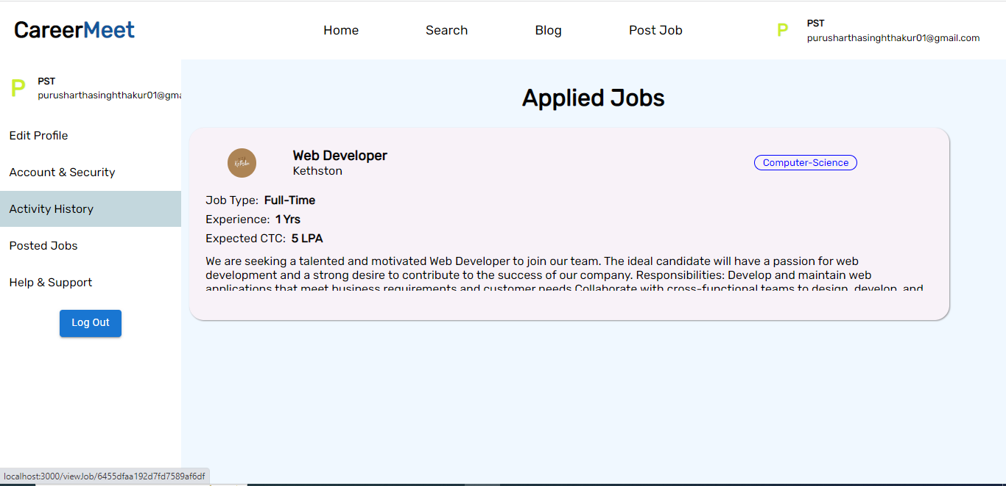

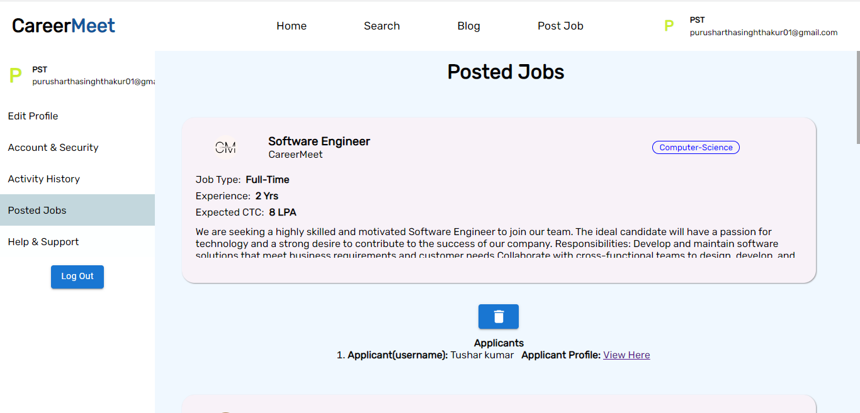

Profile Preview

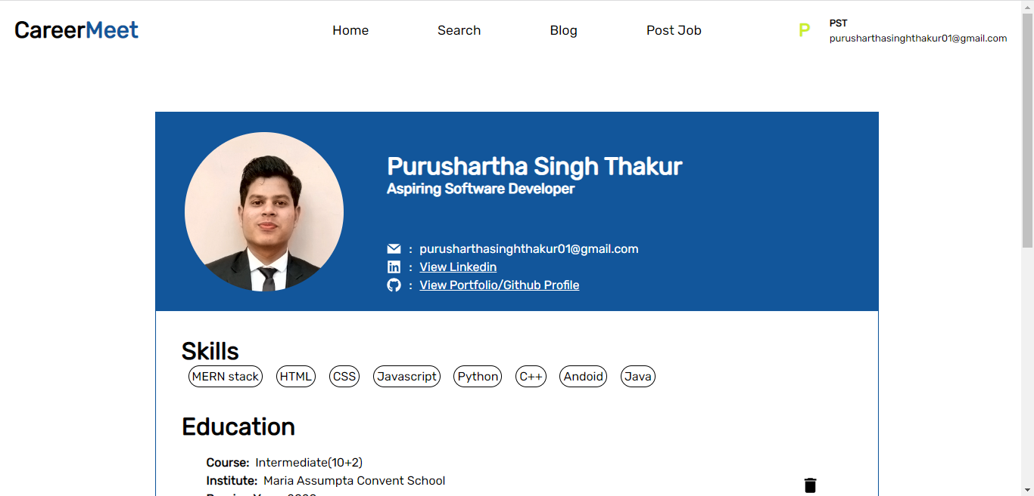

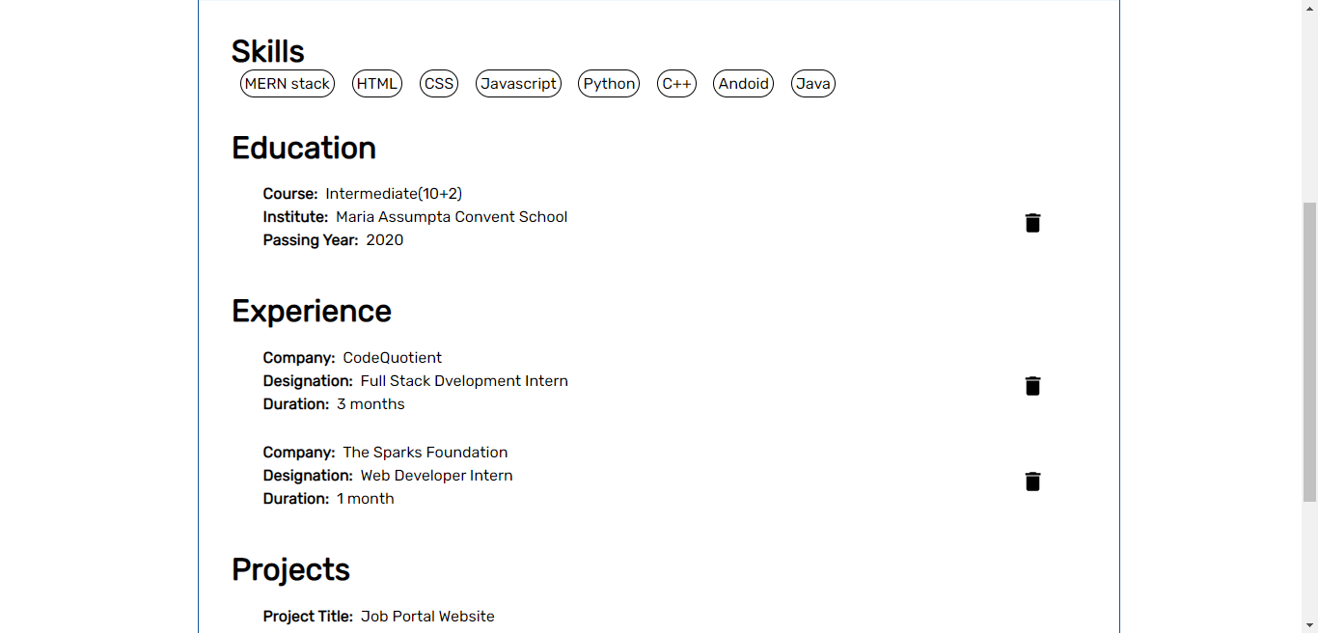

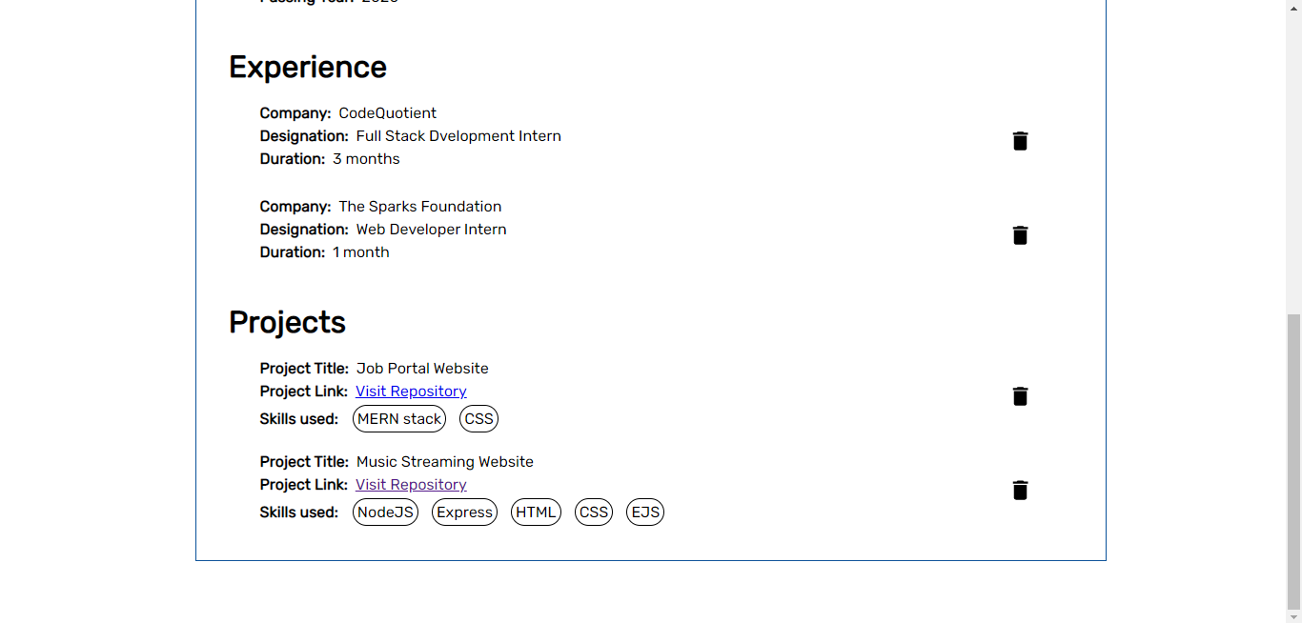

Profile

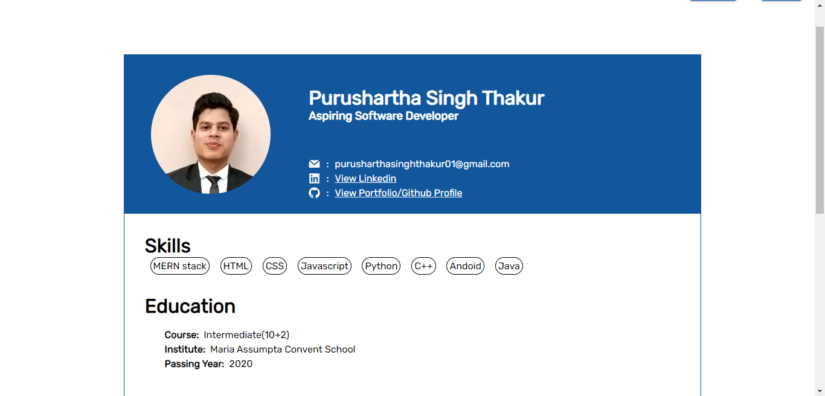

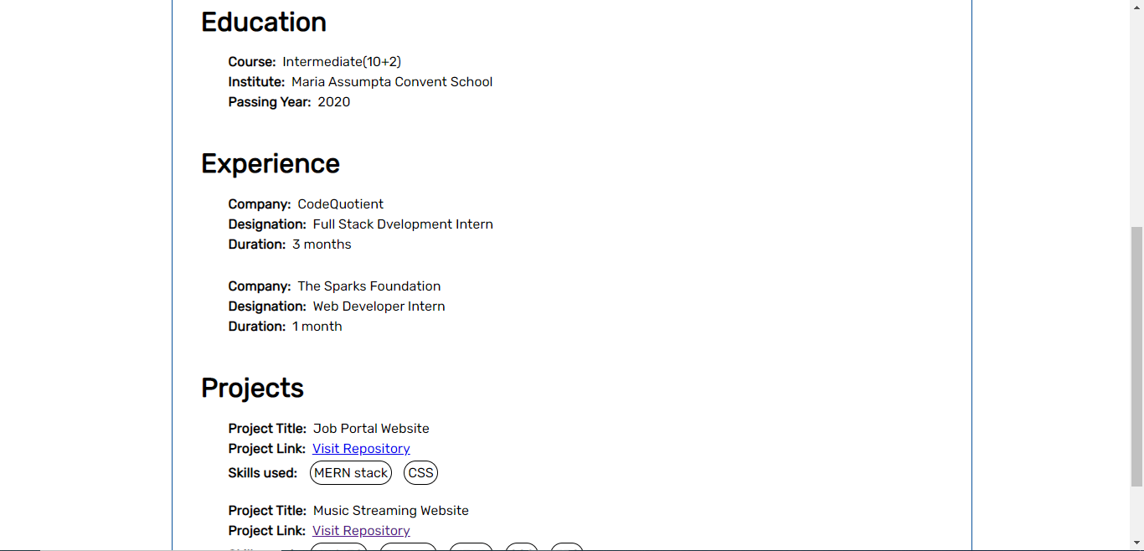

Create Job Post

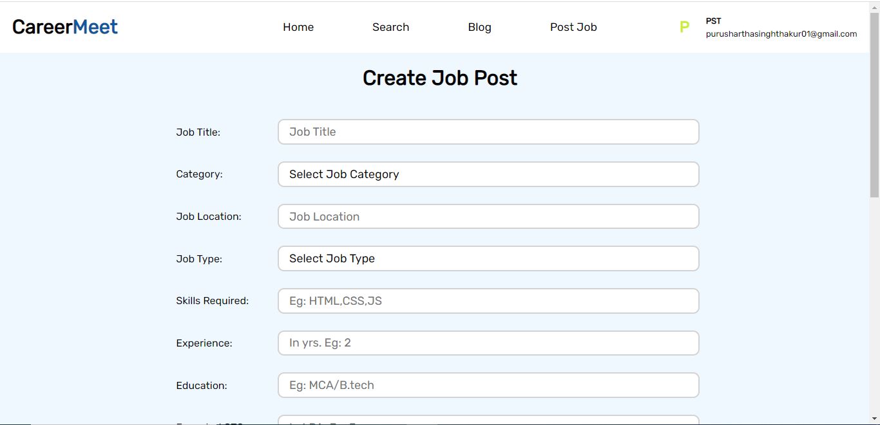

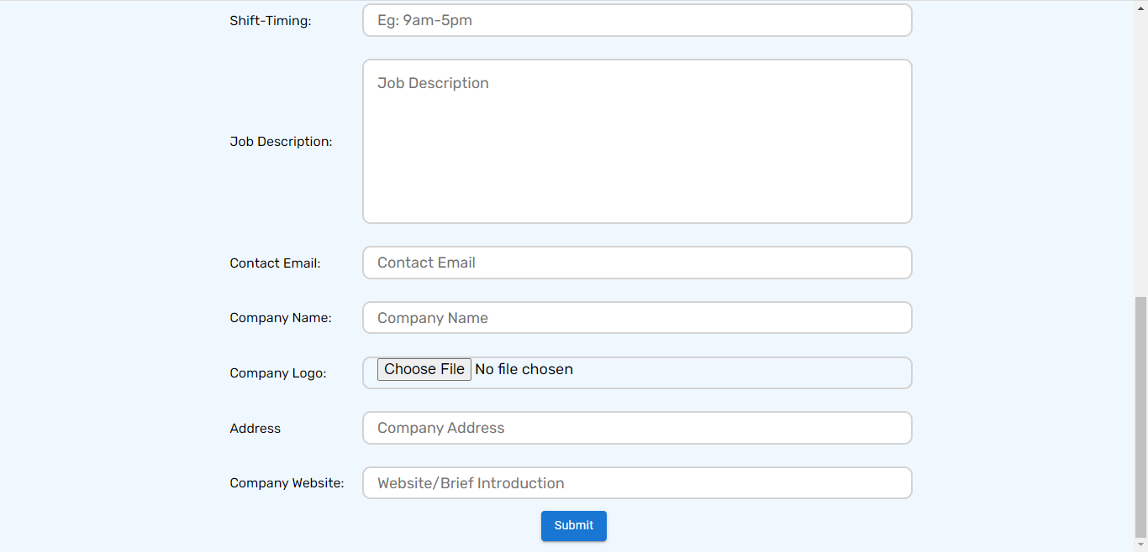

View Job Post

